A Student Guide to Using Microsoft Teams

Section 1 - How to access teams on your computer
Section 2 - Using Microsoft Teams to access a live lesson
Section 3 – Our Expectations During Live Lessons
Section 4 – Uploading Assignments
Section 5 – Using Teams on a tablet or phone
Section 6 – Usernames and Passwords (including reset)

Section 1 - How to access Teams on your computer

On any web browser (Chrome, Safari, Firefox e.t.c) go to https://www.office.com/ and click on the “sign in” button. You will be asked for your username (your FULL Snaith School E mail address such as 21smithJ@thesnaithschool.org.uk) and password (the same one that you use in school for access to printers and other devices).
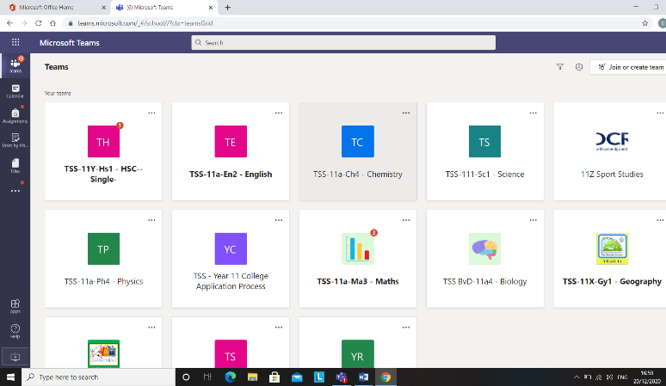
- Once you are logged in, you will be given the option to use a wide variety of Office Apps. In this case, select the ‘Teams’ logo. You will see all the ‘teams’ (classes) that you are a member of.

2. The ‘files’ tab is a files section of useful materials and documents and works a bit like browsing your own computer.
3. If you see “class notebook” that is exactly what it sounds like – a notebook for resources, tasks and communication. Browse it like you would a book and look out for useful information and files.

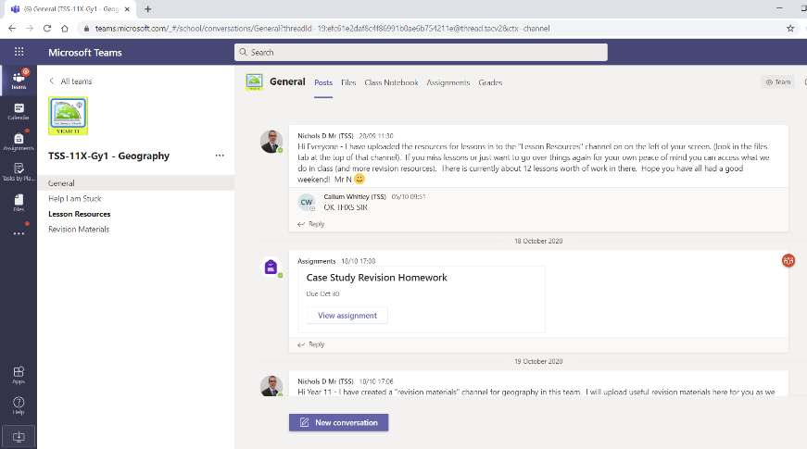
5. Another tab to be aware of is called “assignments” and this is where you will find work set by your teacher outside of the live lessons, including homework
4. Within each ‘team’ you will find channels on the left hand side. The most common channel is called “general”. There may be others that your subject teacher has inputted. You will also find a number of tabs along the top.
Section 2 - Using Microsoft Teams to access a live lesson
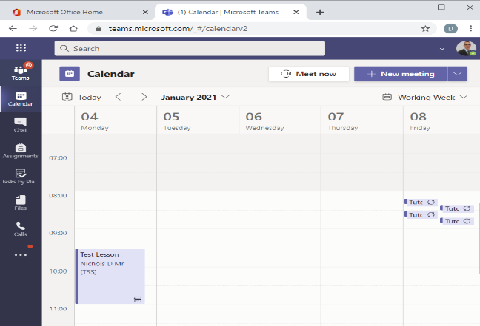
- Once you are logged into teams, your teachers will have scheduled your lessons in advance. You can see these lessons by clicking on your calendar on the left hand navigation panel.

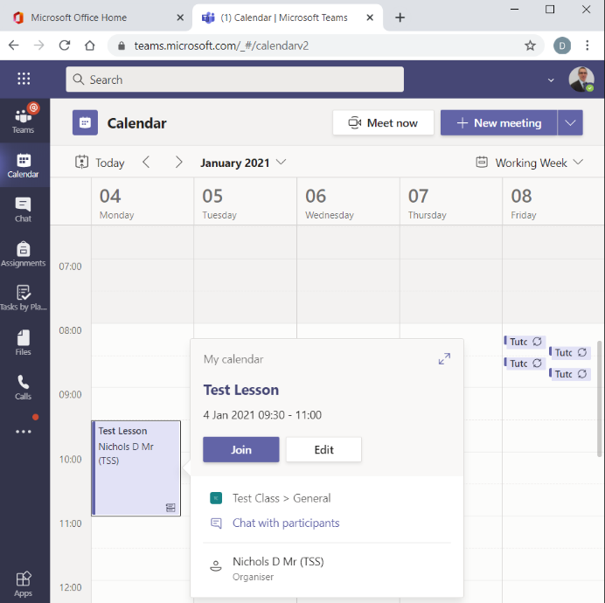

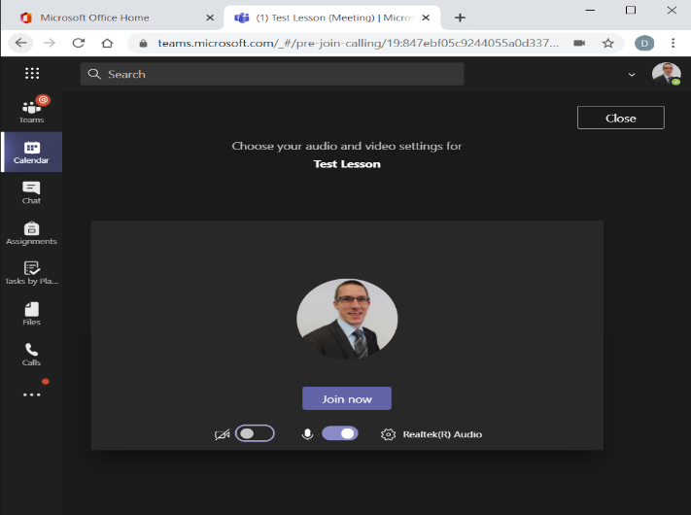
Section 3 – Our expectations during live lessons
2. You can now see your lesson on the calendar.

3. Click on it and you will be offered the opportunity to “Join”. Click on this button.

4. You will be given the option to choose your audio device. When you are happy, click on the “Join Now” button and you will be taken to your lesson. When the lesson is finished, click on the red “leave” button.

Once you are logged into the lesson, wait patiently for other members of the group to arrive. Your teacher will deliver the lesson to you and you can interact in the normal way by answering questions and asking when you don’t understand something. As in all lessons, you should remember the following:

- You are expected to remain on ‘mute’ unless the member of staff taking the lesson asks you a question. This prevents noise from 30 microphones disrupting the lesson.
- Your camera is locked to “off” and this cannot be changed. This ensures the safety of our students and staff.
- If you need ask a question, you can ‘raise your hand’ in the meeting or ask a question in the ‘chat’ box. This can be really useful if you don’t quite understand something.
- Behaviour expectations during the lesson are the same as they are in class. You should follow instructions at all times and avoid disrupting the lesson through inappropriate use of the technology.
- If you lose connection to the lesson, don’t worry. Take your time and log back in by clicking on the “join” button in your calendar again.
- All lessons are recorded for the safety of staff and students. All comments in the chat are recorded (even if you ‘delete’ them they are visible to staff). If you miss a lesson, it will be saved in the “general” tab and you can watch this later and complete the work in the ‘assignment’ tab in your team.

Section 4 – Uploading Assignments
Your teacher can set assignments for you to complete. You will receive a notification every time your teacher sets a new assignment (see the blue circle below). By clicking on this notification you will be brought to the assignments page where you can see current and completed assignments.

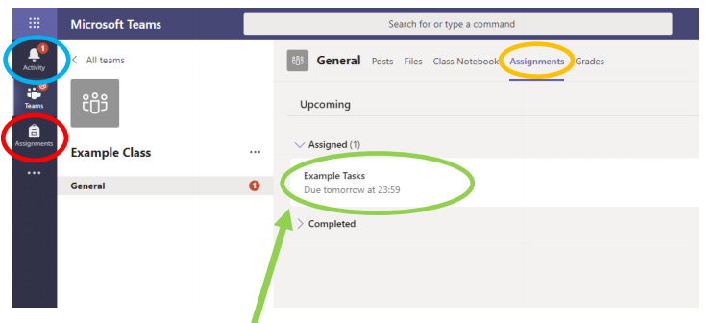
You can also go here directly by clicking on the assignments logo on the left hand navigation pane. (circled here in red) or the assignments tab at the top (circled in orange).
By clicking on the assignment you wish to access you will be taken to the task. Depending on the task and how the member of staff have set this up you may have to edit a document or upload one. You can do this by clicking the “add work” button shown here.
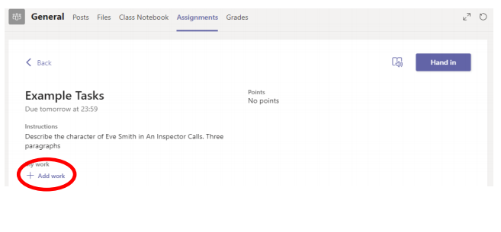

Once you have selected the file that you wish to upload, click the ‘hand in’ button to send this to the teacher. You will have the option to ‘undo hand-in’ if you wish to make further changes.

Section 5 – Using Teams on a Tablet or Phone
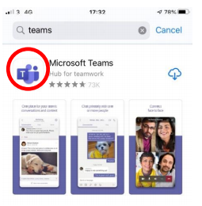
The Microsoft Teams app is available for free download from the app store (iPad / iPhone) or Google Playstore (Android devices). Search for Teams and look for the purple Teams icon. Download it and log in using your usual details. You may also be asked to give permission for the app to use your camera, microphone and send notifications. Allow this.
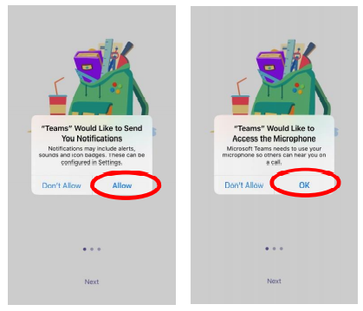

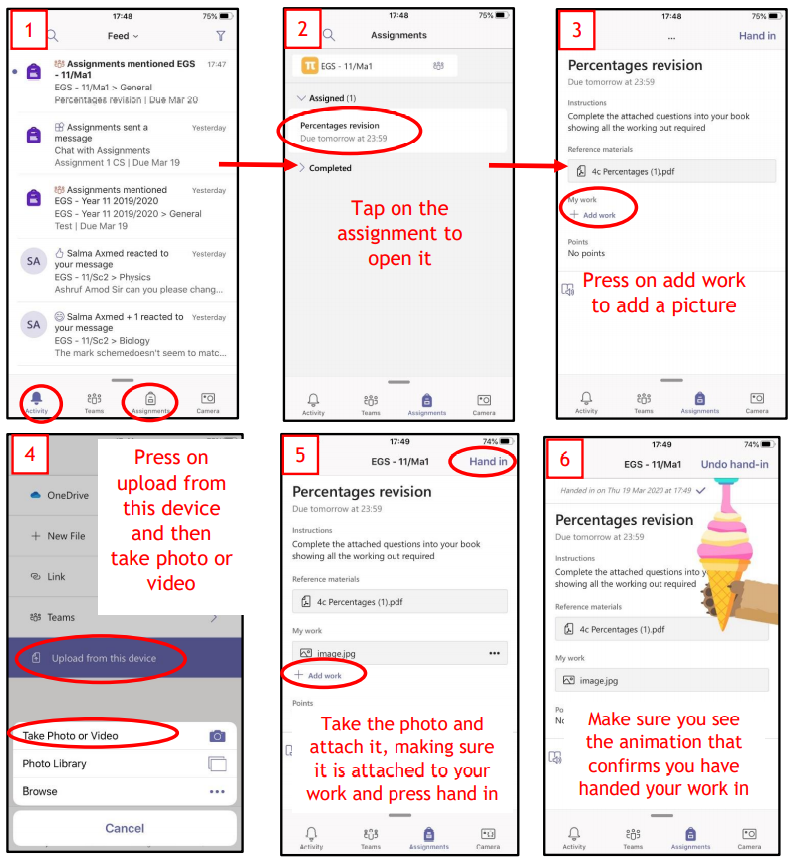
Turning on notifications will allow the app to tell you when you have new assignments and lets you know when your lesson is starting. You can join your lesson from this notification or directly through the app.

You can also submit work through the app in the same way as you can through a computer. It just looks a little different.

If you have completed your work on paper, you can take a photograph of your work and submit this through the app too!

Section 6 – Usernames and Passwords (including reset)
Your user name for teams is your full school e mail address. All student school e mails start with a number and is followed by surname and first initial.

Year 7 – E mails start with 26
Year 8 – E mails start with 25
Year 9 – E mails start with 24
Year 10 – E mails start with 23
Year 11 – E mails start with 22

So John Smith in year 7 would have a teams e mail of 26smithj@thesnaithschool.org.uk and Rebecca Jones in year 11 would have a Teams e mail of 22jonesr@thesnaithschool.org.uk

If students cannot remember their password they will not be able to get into teams to access their learning.
Please E Mail Passreset@thesnaithschool.org.uk from the e mail address you have registered with the school. Please include in the e mail:

- Student Name
- Student Form Group
- Student Login (e.g. 21smithJ)
- Student Date of Birth to confirm security

If you have any further issues, please contact school via telephone (01405 860327) giving details of your students login. We will always try to reset passwords as soon as possible. As this is a manual task, this may not be immediate. Thank-you for your patience.

